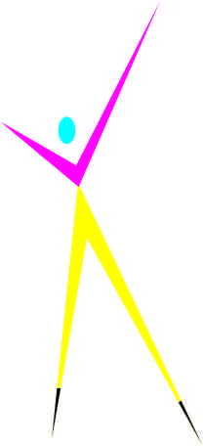

Home Products Contact

**Printing Your needs**

**Kavitha Printers** was established in the year 1979, at Karur, We are known as one of the trusted manufacturers, and suppliers of wide ranging Printing Materials. We fulfill all your needs of Printing works and Binding works.

All type of Single colour / Multicolour / Digital Printing works are done in time by us. Stickers works / Lable works / Badge Stickers / Visiting card printing / Letter head printing / Certificate printing / Pamplet printing / Notices printing / Invitations printing and all type of works done in time with desired quality.

**Kavitha Printers**

44/30, Annai Indira Salai,

Church Corner, Karur – 639 001.

Cell : (0) 98435 91235

G pay / Phone Pay / PayTM : 9843591235

E mail : [kavithaprinters44@gmail.com](mailto:kavithaprinters44@gmail.com)

**Products :**

Visiting card

Letter head

Invitations

Bill Book

Pamplet

Lables & Stickers

Covers

Notice

**Visiting card :**

Thick Card Board

Synthetic

Multicolour

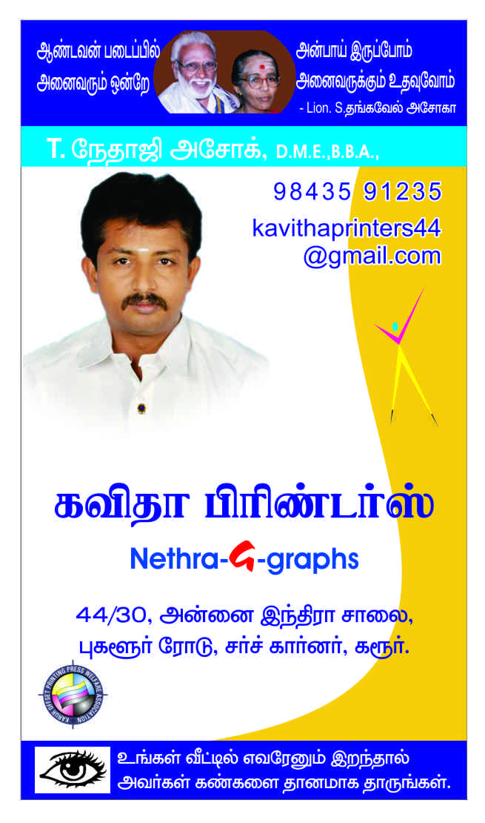

**Letter Head :**

Single colour

Double colour

Multicolour3

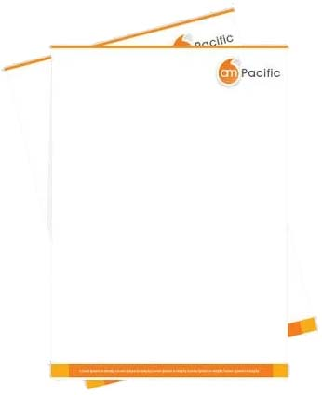

Invitations :

Photo type / Normal

Wedding

Inauguration

Temple Kumbapishegam

All Functions

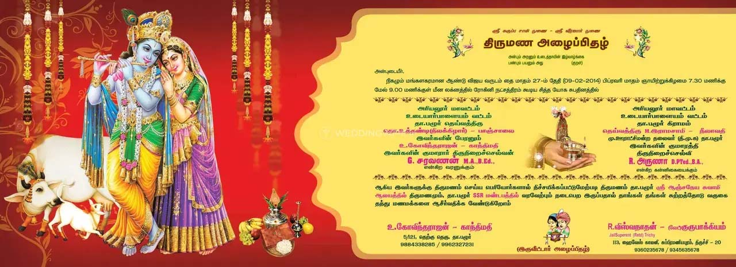

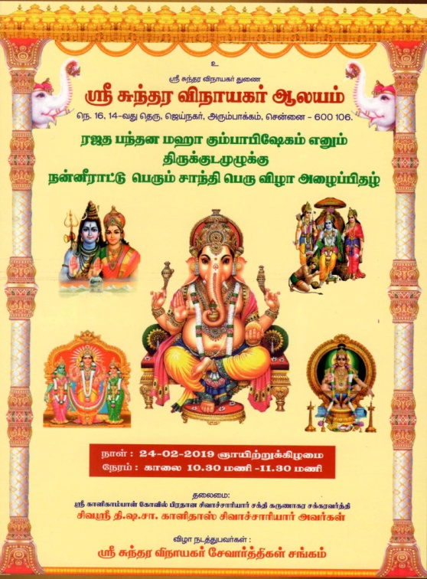

Pamplets :

All Sizes

Company Pamplets

Product Pamplets

Covers :

Office Covers

Vibuthi Covers

All Covers

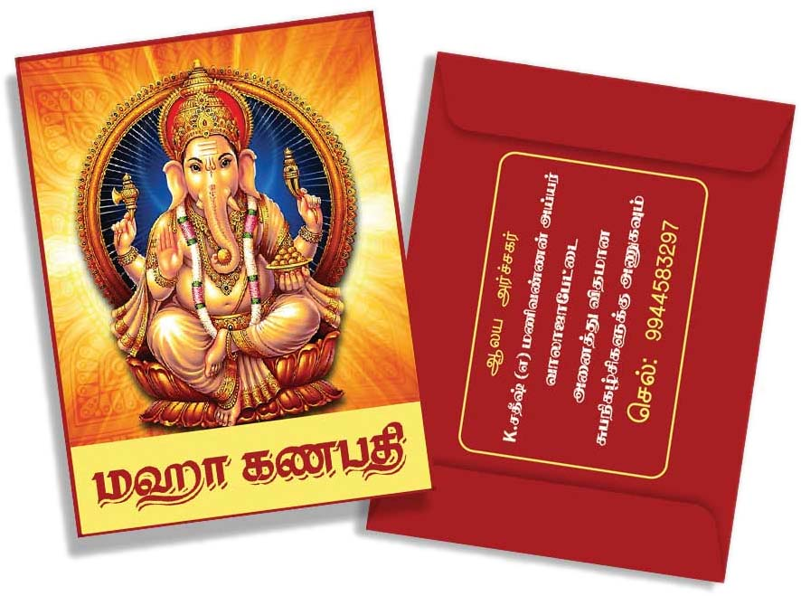

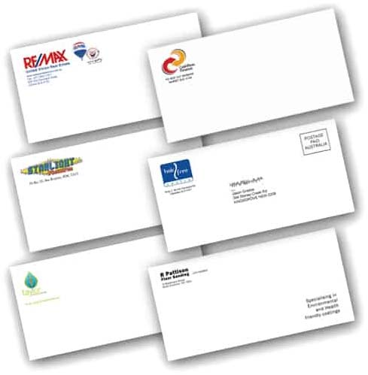

Notice :

Company Notice

Personal Notice

Banking Notice

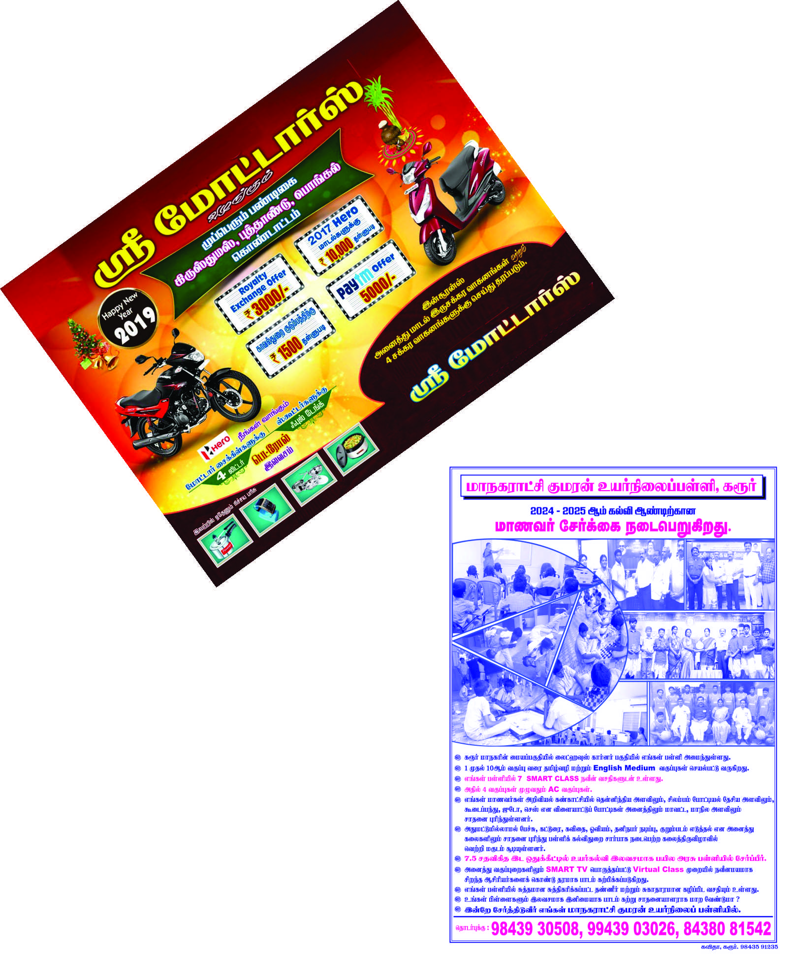

Lables & Stickers :

All types of

Lables & Stickers

Contact :

Kavitha Printers

44/30, Annai Indira Salai,

Church Corner, Karur – 639 001.

Cell : (0) 98435 91235

G pay / Phone Pay / PayTM : 9843591235

E mail : [kavithaprinters44@gmail.com](mailto:kavithaprinters44@gmail.com)

